Deploying your visualisations

Documentation for the Tom.bio ID Visualisation Framework



Dr Richard Burkmar

Biodiversity Project Officer

Field Studies Council

Head Office

Montford Bridge

Shrewsbury

SY4 1HW

richardb@field-studies-council.org

Tel: (01743) 852125

Tomorrow's Biodiversity Project funded by the Esmée Fairbairn Foundation

# Contents

1 Contents 2

2 Introduction 3

3 Sharing by copying between computers 3

4 Deploying to a website 4

4.1 Simple deployment as a standalone page 4

4.2 Deploying to a content management systems (CMS) 5

5 Hosting on the Tomorrow’s Biodiversity website 6

# Introduction

If you develop an interesting taxonomic knowledge-base and you want other people to be able to use it with the Tom.bio visualisations, you need to share the results of your labour somehow. There are three approaches to doing this:

1. sharing locally by copying between computers;
2. deploying to your own website; or
3. hosting it on the FSC Tomorrow’s Biodiversity project website.

Each of these options is described below.

# Sharing by copying between computers

The most straightforward way to share your knowledge-based visualisations with one or just a few people is simply to copy it to another computer. Follow the steps below.

1. **Copy the entire tombiovis folder** (e.g. tombiovis-1.0) to a memory stick or some other media and copy it from here onto another computer. Alternatively you could zip the folder up and email it but, this could be quite a large file – especially if you have used a lot of images – so be cautious about this.

The above step is similar to the first step you took when installing the framework on your computer, i.e. downloading and unzipping the framework, only this time it includes the knowledge-base you’ve created. The remaining steps are exactly the same as installing the framework for the first time on any computer.

1. **Install Node.js**, <https://nodejs.org/en/download>, on the new computer.
2. In the tombiovis folder (e.g. tombiovis-1.0), **execute server-setup.bat** (e.g. by double-clicking it from Windows explorer). This may take up to a minute or so to run.

As you certainly know by now, the above three steps are ‘one-off’ but the following two are required whenever you want to run your visualisations on the new computer.

1. In the tombiovis folder (e.g. tombiovis-1.0), **execute server-run.bat** (e.g. by double-clicking it from Windows explorer).
2. **Start the visualisation** by entering the following URL into your web browser: <http://localhost:8080/vis.html>

An alternative to the above steps is simply to get the owner of the computer onto which you are copying your knowledge-base to follow the Quick-start Guide to install the framework on their computer and then to copy just your knowledge-base folder into the kb folder. You will also need to update the ‘vis.html’ file, e.g. by replacing it with yours, so that it points to the new knowledge-base.

To change the appearance of the page around the actual visualisation, e.g. the title **Tom.bio ID Visualisation test page** and **footers**, you need to edit the vis.html file. You don’t need much of an understanding of HTML (the ‘mark-up’ language of websites) to do this if you are making very simple changes such as changing the title and removing the ‘footers’ text. But if you want to make more sophisticated changes, you will need to either have better understanding of HTML or seek help from someone that does.

# Deploying to a website

## Simple deployment as a standalone page

Deploying to a website isn’t so very different from deploying to a computer. In fact in some respects it’s simpler because you do not have to use Node.js to set the computer up as a local web server.

1. **Make a copy your entire tombiovis folder** (e.g. tombiovis-1.0) on your computer and rename it, e.g. to tombiovis-web.
2. **Delete the following files and folders** from this new folder:
   1. Documents folder
   2. Node_modules folder
   3. LICENSE file
   4. README.md file
   5. 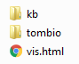server-run.bat file
   6. server-setup.bat file
   7. server.js file

This will just leave the ‘vis.html’ file and the kb and tombio folders.

1. **Delete any unwanted knowledge-bases**, e.g. biscuits, from the kb folder.
2. **Copy the new folder** (e.g. tombiovis-web) **to your webserver** below the root directory representing your domain.

If I was doing this on the Tom.bio website, for example, I could copy the tombiovis-web folder to the ‘sites’ folder shown below in a screenshot from FileZilla.

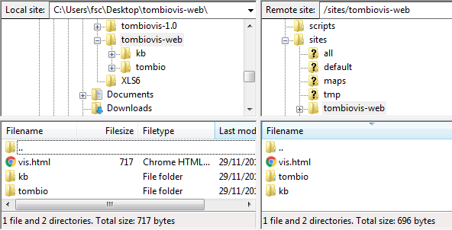

This would give me a URL for my visualisation of: <http://www.tombio.uk/sites/tombiovis-web/vis.html> (see below).

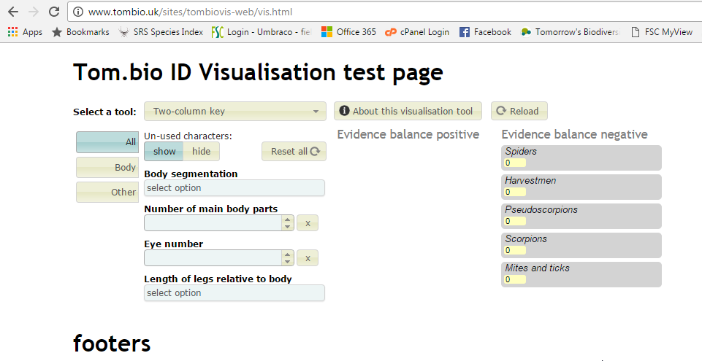

If you want to change the appearance of the page around the actual visualisation, e.g. the title **Tom.bio ID Visualisation test page** and **footers**, you need to edit the vis.html file (see the previous section).

## Deploying to a content management systems (CMS)

Deployment to a Content Management System (CMS) such as Drupal, Wordpress, Joomla or Umbraco is a little more involved and what you do will depend on your CMS and it’s configuration on your site. If you are even reading this section it suggest that you know something about your CMS – if not then you need to seek help from your webmaster – showing them this installation guide.

The contents of the vis.html file are shown below:

<!DOCTYPE html>

<html lang="en">

<head>

<meta charset="utf-8">

<title>Tom.bio ID Visualisation</title>

<!--Change the tombiopath variable to match the installation environment-->

<script>var tombiopath = "tombio/"</script>

<!--Change the tombiokbpath variable to pick up the KB you are working with-->

<script>var tombiokbpath = "kb/biscuits/"</script>

<!--Change the path to load.js to match the installation environment-->

<script type="text/javascript" src="tombio/load.js"></script>

</head>

<body leftmargin="100px">

<h1>Tom.bio ID Visualisation test page</h1>

<div id="tombiod3"></div>

<h1 style="width: 100%">footers</h1>

</body>

</html>

The important parts are highlighted in yellow and these are the bits that need to be implemented in an appropriate place on your CMS page. The three script tags must be edited appropriately to reflect the installation location of the framework.

The ‘load.js’ script is responsible for loading and starting the framework and it replaces the contents of the ‘<div id="tombiod3"></div>’ tag with all the dynamically created visualisation markup – so place this tag where you actually want the visualisation to appear within your page.

### Other considerations when hosting on CMS pages

If you host framework visualisations within the context of a CMS page it is quite likely that you might have to make some adjustments to the CSS styling rules that are incorporated within the framework. Sometimes the CSS that creates the general look and feel of your CMS website affects the look and feel of the framework visualisations in unexpected ways and you might have to adjust or add further CSS to the framework stylesheets to fix this.

Most of the framework’s CSS currently resides in the file ‘tombio/tombiovis.css’ although some visualisations have their own CSS in their corresponding sub-folder.

# Hosting on the Tomorrow’s Biodiversity website

If you don’t have a website that you can deploy to, you can ask the FSC’s Tomorrow’s Biodiversity project to host the visualisation for you.

We will host on a page that makes it clear that we are only providing a hosting service and that the knowledge-base, and responsibility for it, is yours.

We will only ask you to confirm that nothing we are hosting on your behalf infringes anyone’s copyrights or intellectual property rights.